**PRACTICAL NO. 3**

**AIM: CRUD USING MONGODB**

**Creating a New Database:**



Creating a collection:



**Insert records:**

1.Insert one

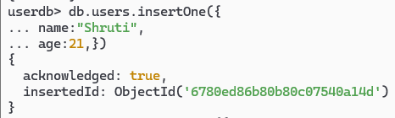

2.Insert Many

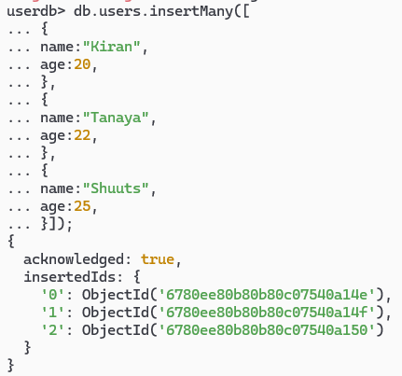

OUTPUT:

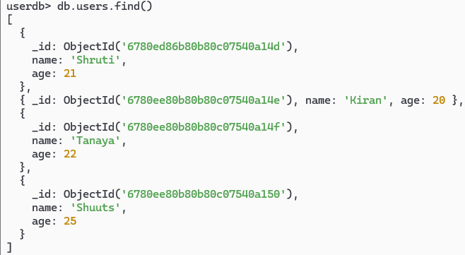

READ OPERATION

1.find

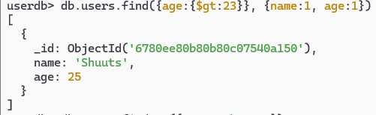

2.findOne

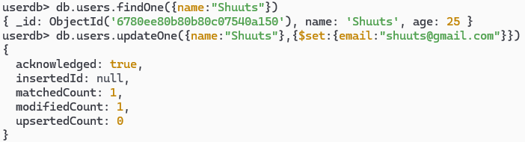

UPDATE:

1.updateOne

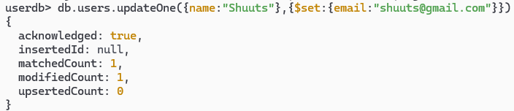

2.updateMany

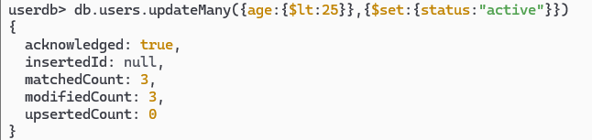

OUTPUT:

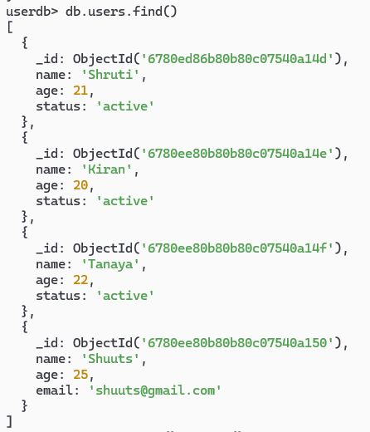

DELETE

1.deleteOne

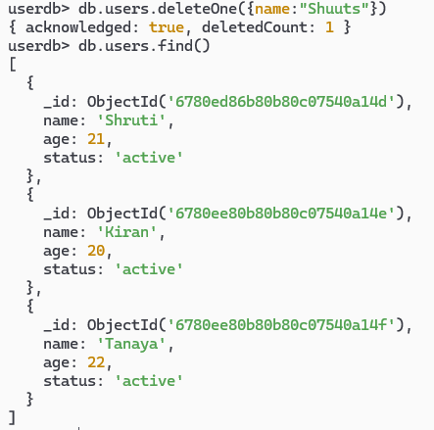

**2.deleteMany**

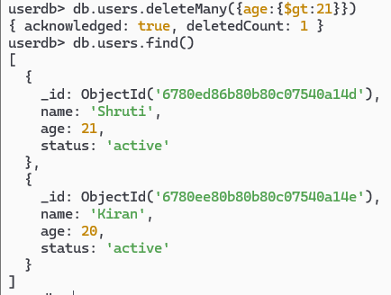

**DROP**

